

**Contacts:**

Michelle Sparacio Ben Arens

Weil-McLain L.C. Williams & Associates

312-485-3749 312-565-4626

[msparacio@weil-mclain.com](mailto:msparacio@weil-mclain.com) [barens@lcwa.com](mailto:barens@lcwa.com)

**Ontario Office Building Achieves Optimal Heating Performance,**

**Increases Efficiency with Upgraded Boiler System**

A multi-story office building in Ontario sought to upgrade its two-stage boiler and replace its direct-fired water heater to eliminate short cycling, improve efficiency and provide heating redundancy. Four high-efficiency boilers and one stainless steel indirect-fired water heater from [Weil-McLain Canada](https://weil-mclain.ca/?utm_source=weil+mclain+ontario+building+case+study+2022+lcwa&utm_medium=email&utm_campaign=weil+mclain+ontario+building+case+study+2022+lcwa) provided the remedy needed.

“The water heater was deteriorating rapidly, and the boiler was only running at about 85% efficiency,” said Darrel Gillespie, owner and president of Triple Tech Heating, Air Conditioning and Refrigeration, the HVAC contracting firm who handled the project.

Laying the Groundwork for Optimal Heating Efficiencies

Collaborating with [Weil-McLain](https://www.weil-mclain.com/?utm_source=weil+mclain+ontario+building+case+study+2022+lcwa&utm_medium=email&utm_campaign=weil+mclain+ontario+building+case+study+2022+lcwa), North America’s leading boiler manufacturer, the Triple Tech team installed four floor-mounted Weil-McLain 399MBH [Evergreen™](https://www.weil-mclain.com/products/evergreen-pro-gas-boiler?utm_source=weil+mclain+ontario+building+case+study+2022+lcwa&utm_medium=email&utm_campaign=weil+mclain+ontario+building+case+study+2022+lcwa) boilers complete with 24V low-water cutoffs (LWCO) and innovative control systems, as well as boiler circulator and system supply and outdoor sensors. Complementing the boiler system was the installation of an 85-gallon [Aqua Plus®](https://www.weil-mclain.com/products/aqua-plus-series-2?utm_source=weil+mclain+ontario+building+case+study+2022+lcwa&utm_medium=email&utm_campaign=weil+mclain+ontario+building+case+study+2022+lcwa) indirect-fired water heater with a digital thermostat and a temperature/pressure relief valve also from Weil-McLain Canada.

“The previous boiler, at two million BTUs, could only be serviced by a G1 tech, which are not readily available,” said Gillespie. “If the boiler went down, the building would be without heat; however, with four boilers that can be serviced by a G2 tech, if one needs to be repaired, three more will still run to ensure redundancy and back-up.”

Featuring 96.5% combustion efficiencies, the durable Evergreens are designed with cutting-edge technology, easy-to-setup controls and flexible functionality for multiple applications to properly match heating loads and contribute to energy savings. Easy to install, use and maintain, they are adaptable for most heating needs, including commercial or large residential applications, and for single or multi-boiler installations.

Additionally, the boilers feature the intuitive and user-friendly Unity™ control system with a built-in lead-lag rotate sequencer that can be used to control various units in a multi-boiler system. The control allows minimum and maximum firing rates to be adjusted for different priorities, which allows contractors to individually customize boilers for each installation. For this installation, the domestic hot water (DHW) maximum firing rate was reduced to match the maximum input of the indirect tank at 190,000 BTUH.

“One of the many features our installers like is that no matter the size of these boilers, they can be floor- or wall-mounted,” said Gillespie. “Some boilers in this size-range can only be wall-mounted, which can limit their placement in the room. Being able to install them on the floor helps us save on manpower and labor costs since multiple technicians are not needed to mount them on the wall.”

Increasing Efficiency While Decreasing Fuel Consumption

To better generate DHW and reduce boiler fuel consumption, an 85-gallon Aqua Plus indirect-fired water heater was also installed. Featuring high output stainless steel heat exchangers that deliver superior first hour ratings and recovery, the unit’s compact size allows for easy installation in low ceiling basements or storage rooms and comes equipped with pre-installed thermostat connections for quick wiring. The digital thermostat ensures precise accuracy for optimal performance while a temperature/pressure relief valve automatically releases water if the pressure or temperature in the water tank exceeds safe levels.

“The ability to install smaller, fully modulating condensing boilers and water heaters is key to energy savings and improved comfort level because modulating means less on/off cycling and consistent building temperatures,” noted Gillespie. “The boilers and water heater will perform according to the building’s heat loss in combination with outdoor temperatures.”

Top-Notch Performance in One Unified System

The total system turn-down of 40 to 1 allowed the boilers to better match the heating load of the building while the 96.5% thermal efficiency increased performance up to 20% and eliminated short cycling. Furthermore, using the new Evergreen boilers in conjunction with the Aqua Plus water heater is expected to provide a gas reduction of 25% over the previous direct-fired water heater. To maximize the usability of the space, the new equipment was installed along a perimeter wall instead of in the middle of the room.

“Combining the boilers and tank like we did for this project optimized performance greatly,” said Gillespie. “With the boiler and indirect tank, we’re getting top efficiency in one package.”

# # #

Old Water Heater

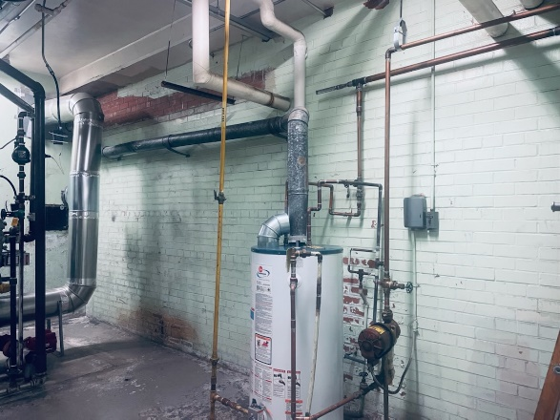

Old Boiler

New System

